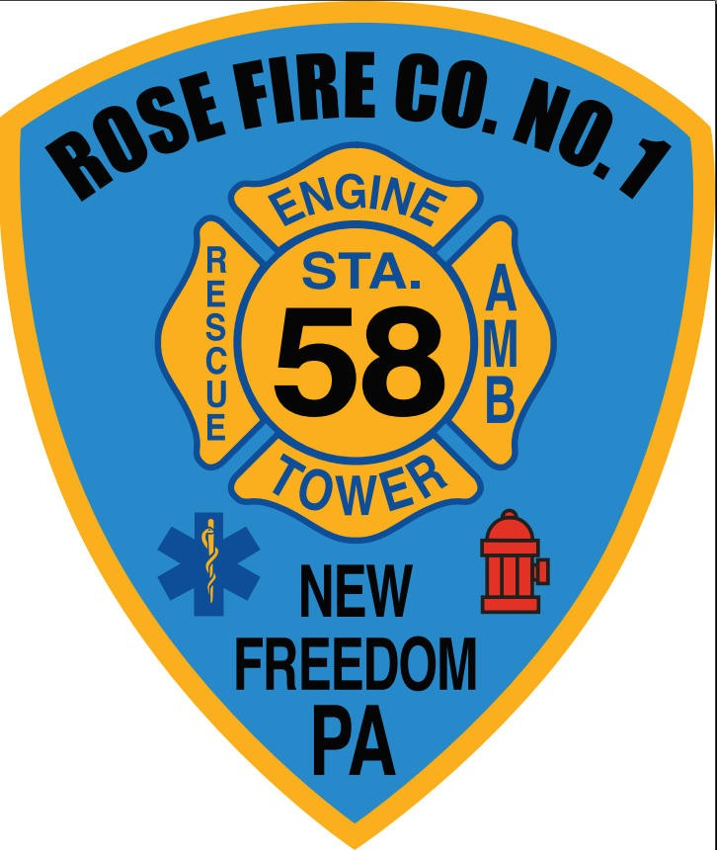ROSE FIRE COMPANY NO. 1,
NEW FREEDOM BORO, YORK CO., PA

Application for Membership

Rose Fire Company No. 1, New Freedom Borough, York Co., PA (“Rose Fire Company”) considers applications for employment/membership without regard to race, color, national origin, ancestry, religion, sex, age, disability, political belief, military service, citizenship, or any other protected class.

I am applying for:

_______ Fire Fighter Membership _______ Social /Auxiliary Membership

______ EMT / Paremedic Membership _______ Fire Police Membership

_______ Junior Membership (must be 14 yrs. of age or older)

PLEASE PRINT

PERSONAL INFORMATION

Name: Date:
(Last) (First) (Middle)

Social Security Number: ________-_____-________ DOB: ___________________________

Address:

City: State: Zip Code:

Telephone Number: Email:

Are you at least 18 years of age? YES NO

If applying for Junior Membership, are you at least 14 years of age and less than 16 years of age?

If applying for Junior Emergency Responder Membership, are you at least 16 years of age?
If you are not at least 18 years of age, a parent or legal guardian must sign this Application (in addition to the Applicant), and, if you are still in high school, you must attach a work certificate.

How did you find out about Rose Fire Company?

Do you have any relatives or friends working/volunteering here? If so, please list:

CERTIFICATION INFORMATION
(List only current certifications - photocopies are needed at interview)

Certification | Certification Number | Expiration Date | Certifying Agency
CPR
EMT/Paramedic
(Circle One)
National Registry
PALS
ACLS
BTLS
EMD
CDL
EVOC/EMS Vehicle Operator
Other: ________

MILITARY

BRANCH OF SERVICE | DATE BEGAN | DATE  ENDED | RANK & DUTIES | DATE DISCHARGED | LOCATION

EDUCATION AND TRAINING

HIGH SCHOOL:

Name: Address:

Years completed:

Did you graduate? YES NO If not, highest grade completed:

Have you received your GED? YES NO

COLLEGE:

Name: Address:

Years completed:

Did you graduate? YES NO If not, highest year completed:

Degree: Major:

OTHER SCHOOL/TRAINING:

Name: Address:

Years completed:

Did you graduate? YES NO If not, highest year completed:

Certificate: License:

Expires: Expires:

OTHER:

EMS/FIRE SERVICE-RELATED TRAINING NOT LISTED ABOVE:

EMS/FIRE AFFILIATIONS:

REFERENCES

Name: Address:

Relation: Years Known:

Telephone Number (including area code):

Name: Address:

Relation: Years Known:

Telephone Number (including area code):

EMERGENCY CONTACT INFORMATION
 | Name | Relationship
 | Day Phone Number | Evening Phone Number

ACKNOWLEDGMENT

I certify that the information I have given on this application is true, complete, and correct, and I understand that any false information or the omission of information may be considered as sufficient reason for my discharge if I become a member or employee. I recognize that completion of this application does not mean that I will be accepted as a member and does not bind Rose Fire Company to accept me as a member. Applications will remain active for six months, after which time re-application will be necessary. If accepted for membership, I agree to abide by all rules, regulations and policies established by Rose Fire Company and its officers and other persons in charge. I understand that, if accepted as a member, my membership is voluntary and may be terminated in accordance with the Rose Fire Company Bylaws, policies, procedures and all applicable laws and regulations. This application is not an agreement or a contract for membership.

I hereby authorize Rose Fire Company to inquire about my volunteer history with former volunteer organizations and to make any further inquiries considered necessary in connection with my application for membership, including a criminal history check, driving history check, child abuse clearance check, elder abuse clearance check, FBI background check, and other such inquiries. I release Rose Fire Company and all informants from all liability resulting from such inquiries. I waive all rights to see or review the information so furnished.

Application Fee: $20 Paid via ____ Cash _____ Check

*Junior Applicants do not pay an application fee.

Applicant's Signature: Date:

Printed Name:

Signature of Parent or Legal Guardian (if under 18):

*All Members will be on a 6-month probation period from the date the application is accepted by
OFFICIAL USE ONLY
Membership Application, Accepted or Denied
Circle one

Application received by: Date:
Date Interviewed:
Voted in on: , 20____ as a member of the Rose Fire Co. #1
Background Check cleared: _____ Yes _____ No
Membership Committee Member: ___________________________________ Date: _____________________________
President: _____________________________________ Date: _____________________________
Secretary: _____________________________________ Date: _____________________________
Rose Fire Co. #1 membership.

